SIMATS ENGINEERING
ASSESSMENT TOOL 3 - LOW (CAPSTONE PROJECT)

COURSE CODE: CSA09 COURSE NAME: Programming in Java

COURSE OUTCOME COVERED

CO5: Construct database-driven web applications by implementing JDBC connectivity to perform SQL operations such as insert, update, and delete using different statement types. (BL3,BL6)

Assessment Tool Weightage: 40%

QUESTIONS: 1 Total Marks: 100

ANNEXURE A

CAPSTONE PROJECT

Code of Conduct:

I k lohithkumar(192511155) certify that this submission is my original work and that I have adhered to the guidelines specified for this assessment. I understand that any violation of academic integrity rules will result in disciplinary action.

k.lohith kumar
Signature of the student:

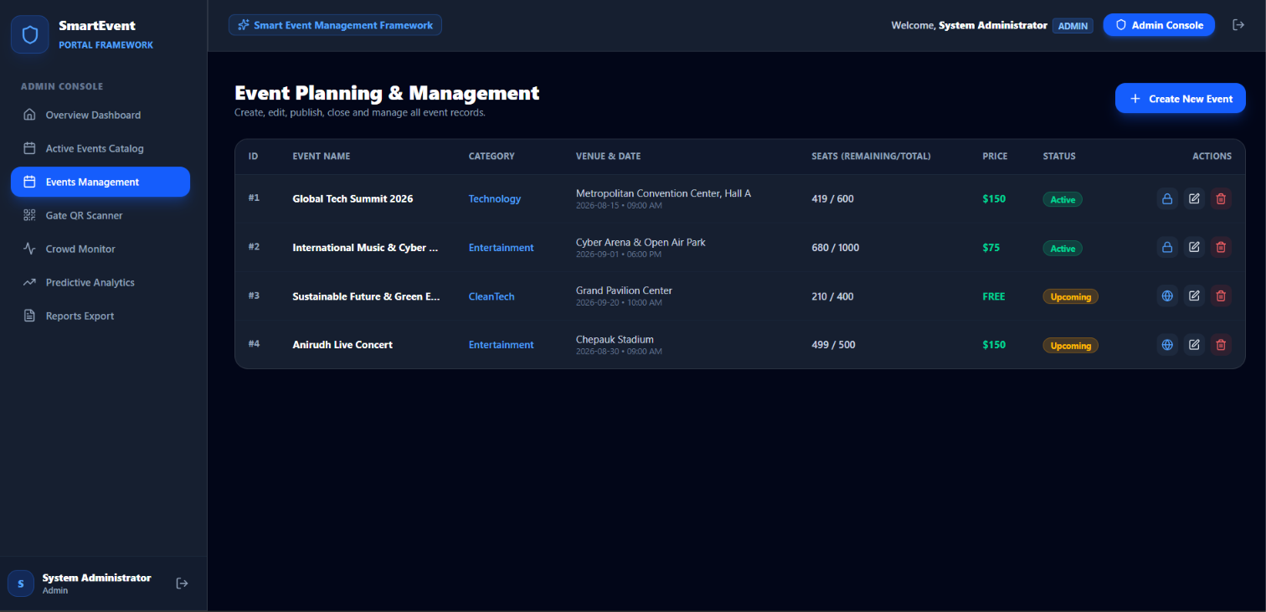

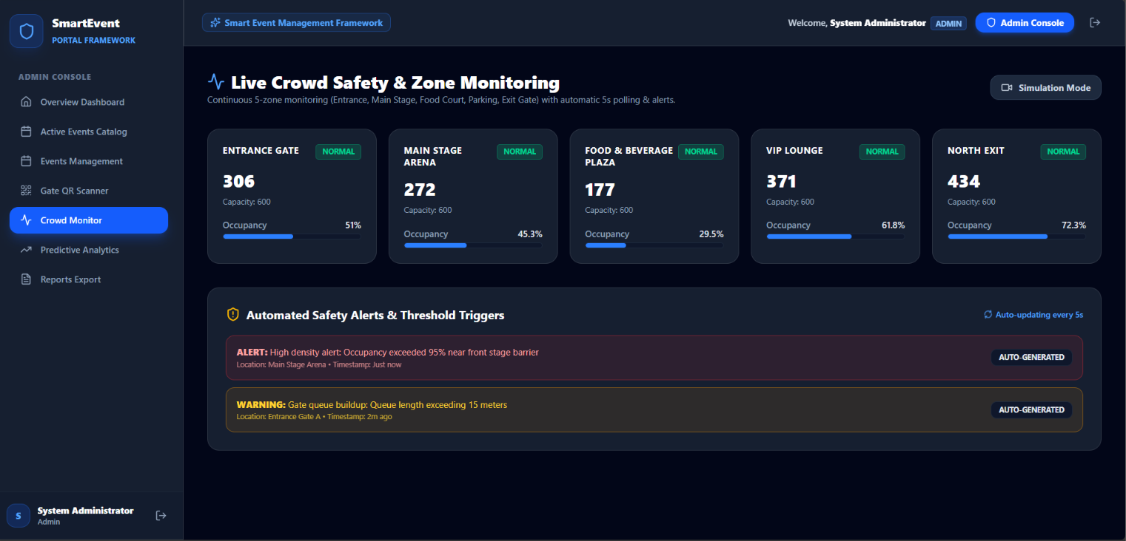

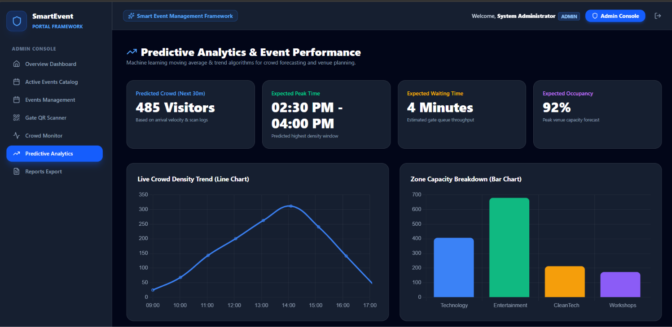

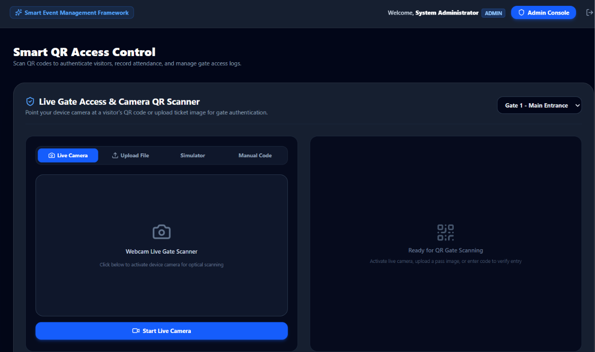

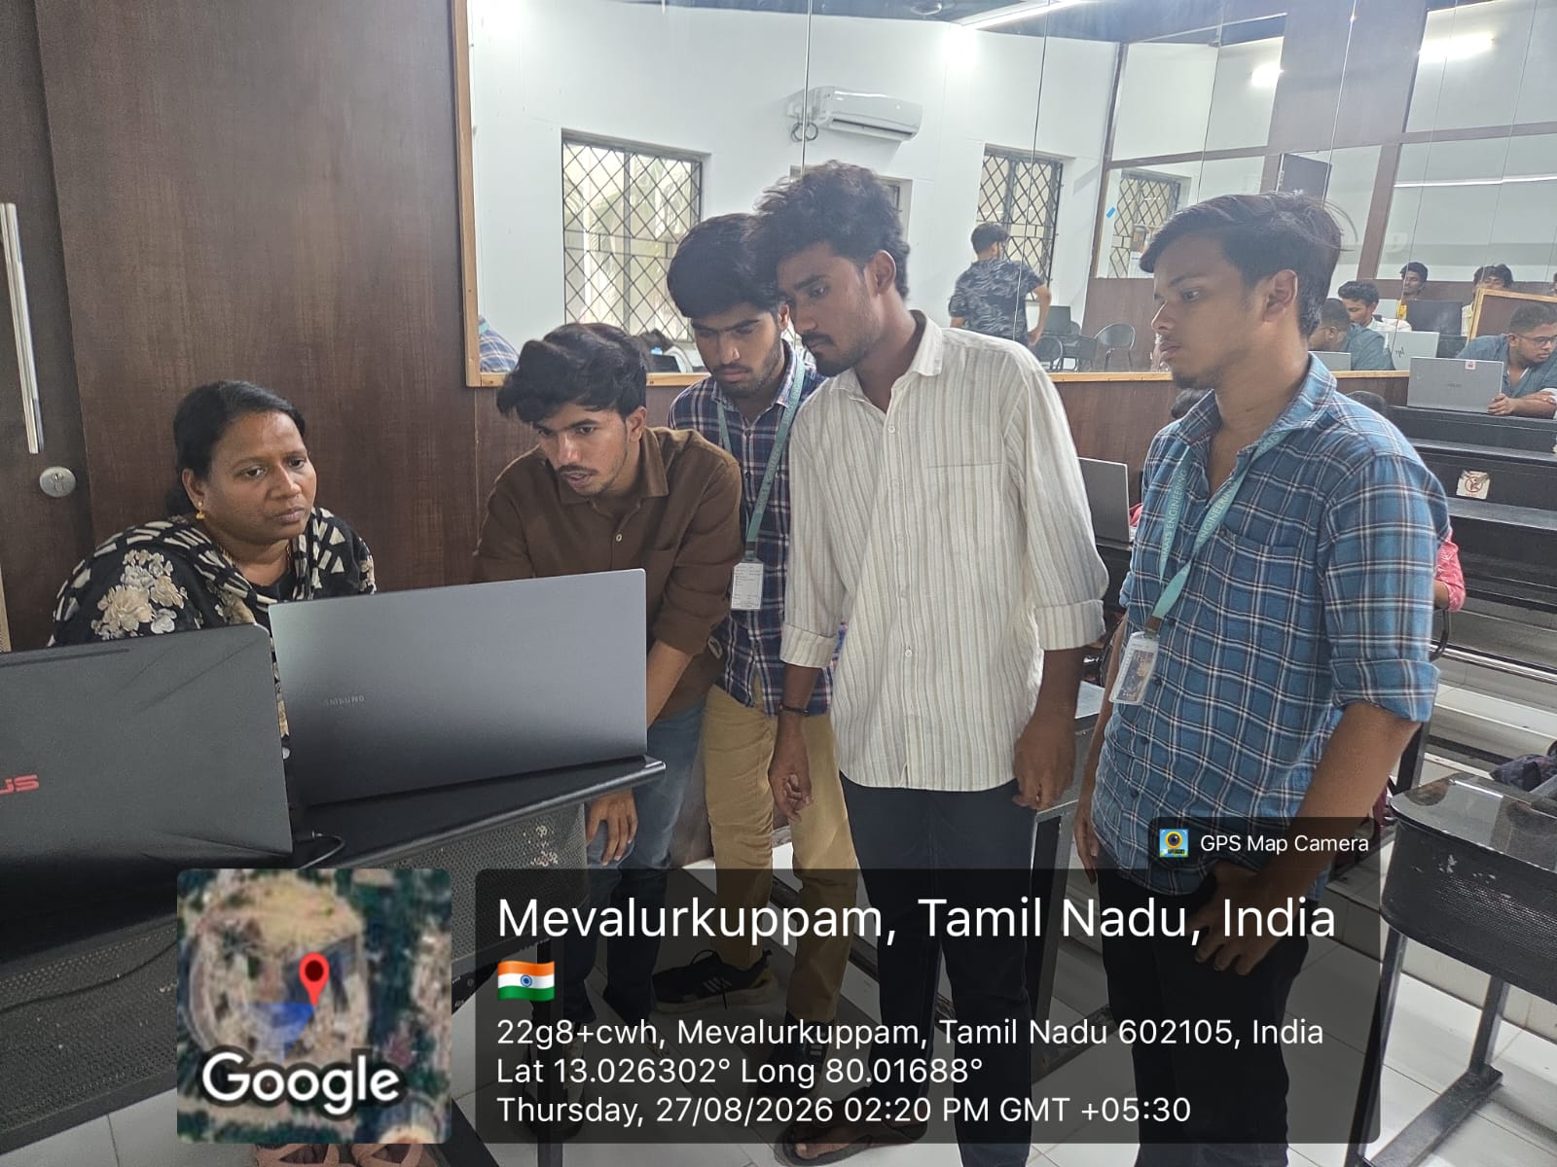

RUBRICS FOR CALCULATION

Criteria | Weight age | Level 4 – Exemplary | Level 3 – Proficient | Level 2 –  Developin g | Level 1 – Beginning
Problem Statement & Innovation | 20 | Clearly defines the problem and presents an innovative, practical solution. | Defines the problem with a relevant solution. | Problem is partially clear with limited innovation. | Problem statement is unclear or irrelevant.
Technical Implementation | 30 | All modules are fully functional, integrated, and technically accurate. | Most modules function correctly with minor issues. | Core functionality is partially implemented. | Implementation is incomplete or incorrect.
Presentation & Communication | 20 | Well-organized, confident delivery with effective visuals and time management. | Clear presentation with good organization. | Presentation lacks clarity or consistent organization. | Poorly organized and difficult to follow.
Demonstration & Results | 30 | Successful live demonstration with accurate, validated results. | Demonstration works with minor functional issues. | Partial demonstration with limited validation. | Demonstration fails or results are incorrect.

